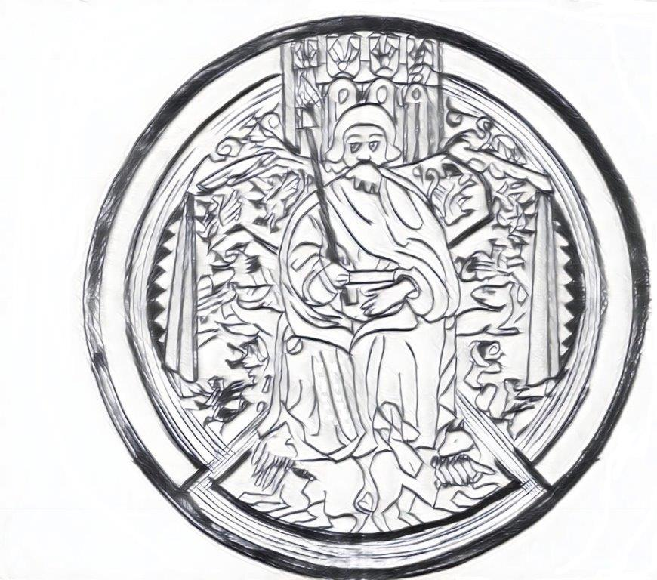

MINUTES OF THE ORDINARY MEETING OF
Machynlleth town COUNCIL
by video conferencing
on wednesday 10th march 2021 at 6.30pm
PRESENT | APOLOGIES
Cllr M Atkins  Cllr G Davies  Cllr R Gaskell  Cllr A Jones  Cllr A Macgarry  Cllr M Rowlands  Cllr J Paige  Cllr M Williams  Cllr G Jones | Cllr J Honeybill  Cllr G Jenkins

ALSO IN ATTENDANCE
Mr. Gwilym Rippon (locum clerk) | Julie Humphreys (Minute Taker)
There were five members of the public present.

 | Agenda item
039-21 |  | ATTENDANCE AND APOLOGIES
 |  | See list above.
040-21 |  | DECLARATIONS OF INTEREST
Name | Item | Personal | Prejudicial
Cllr G Jones | Staffing |  | 8

041-21 |  | CO-OPT NEW MEMBERS  Chair Cllr A Jones welcomed the 3 new Councillors. Due to covid restrictions forms are unable to be signed in the presence of a proper officer Mr G Rippon (locum clerk) asks that forms are signed and left at Y Plas Machynlleth to be forwarded on to him.
042-21 |  | CEMETERY EXTENSION  Locum Clerk Mr G Rippon informs Councillors that Powys County Council purchased land in Presteigne for a new cemetery and he is making enquiries as to who paid for the Legal Work. He states that the Legal Package should be picked up by the unity authority as the land at Y Plas has been gifted to Powys County Council by Machynlleth Town Council. Cllr G Jones has been looking through the minutes and there is no information about the Cemetery. When did Machynlleth Town Council gift the land to Powys County Council? Cllr M Williams states that Machynlleth Town Councillor have agreed to transfer the land to Powys County Council, this needs to move forward for the people of Machynlleth. Cllr G Jones asks why Machynlleth Town Council have not sold the land to Powys County Council. Locum Clerk Mr G Rippon – there are no minutes to state that the land has been gifted. Cllr G Jones – if there are no minutes it means that the land still belongs to Machynlleth Town Council, we are not awash with finance at the moment surely the land should be valued? Cllr M Williams reminds councillors that Y Plas and grounds cost Machynlleth Town Council £1 and he is worried that the town will end up with no cemetery. Cllr G Jones – the delay belongs to Powys County Council not Machynlleth Town Council. Cllr G Jones proposed that Machynlleth Town Council have the land valued Cllr J Paige Seconds. 4 for valuation 5 against. Cllr M Williams formally moves to sell the land for £1 or to gift the land to Powys County Council but that no legal fees are picked up by Machynlleth Town Council. Cllr A Jones proposed Cllr G Davies seconds. 7 voted For, 1 voted Against, 1 Abstained to sell the land to Powys County Council for £1. Locum Clerk Mr G Rippon to arrange a meeting with Powys County Council. All Agreed
 |  | Cllr G Jones and the public left the meeting
 |  | A motion was passed under the Public Bodies (Admission to Meetings) Act 1960 (3) to exclude members of the public during discussion of this agenda item due to the confidential nature of the business discussed

