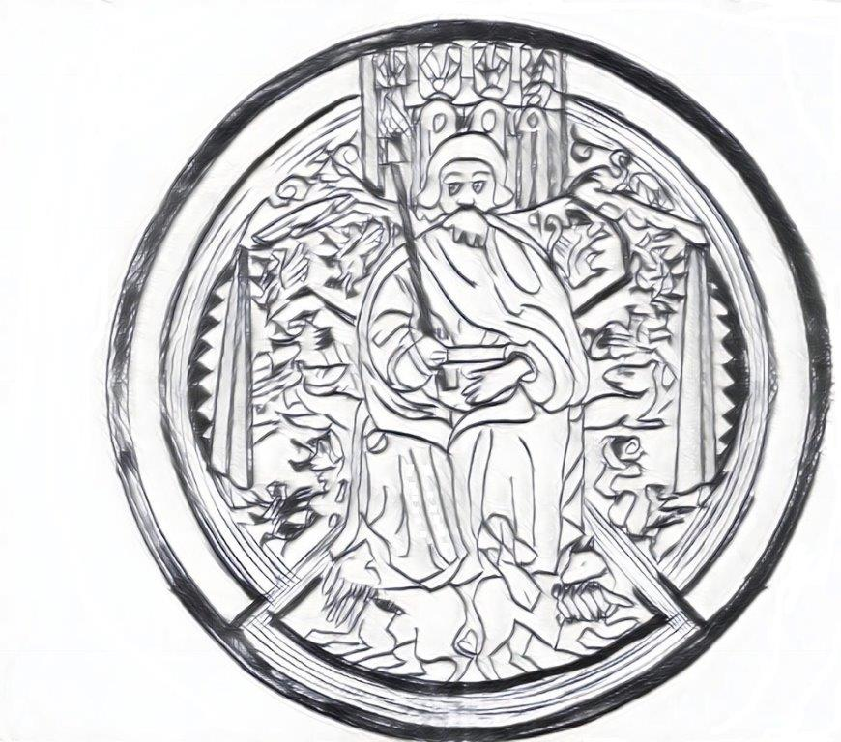

MINUTES OF THE ORDINARY MEETING OF
Machynlleth town COUNCIL
by video conferencing
on MONDAY 26TH APRIL 2021 at 6.30pm
PRESENT | APOLOGIES
Cllr G Jones | Cllr G Jenkins
Cllr T Jones | Cllr M Rowlands
Cllr G Davies | Cllr N Elliott
Cllr R Gaskell
Cllr M Williams
Cllr J Paige
Cllr A MacGarry
Clrr M Atkins
Cllr J Honeybill

ALSO, IN ATTENDANCE
Julie Humphreys (Minute Taker)
There was six members of the public present.

Agenda item
 | ATTENDANCE AND APOLOGIES
 | See list above.
 | DECLARATIONS OF INTEREST
Name | Item | Personal | Prejudicial
Cllr G Jones | Item 17 & Staffing | 8

 | Cllr M Williams MCCP *
 | Cllr G Jones requests that item 17 be moved to the end of the meeting just prior to Staffing. Chair Cllr T Jones Agreed
 | Cllr G Jones states that when Councillors declare an interest it means that we are absolving ourselves from that issue. Once an outcome is reached all Councillors should be informed of the outcome, but not before.
PRESENTATION
To receive a presentation from Machynlleth Community Children’s Project

Angela Makaruk of MCCP takes this opportunity to make Machynlleth Town Council aware of the current situation. The first bid to Lottery Big Build was unsuccessful and they are resubmitting a new application by May 1st.
MCCP is a not-for-profit charity. They are currently set over 2 settings. Nursery for under 3yr olds at the site in the main car park and over 3yr olds are at Ty Melfed. The big issue they have is that they are part of the New Bro Hyddgen School. The School are looking at charging MCCP £4 per hour, our finances are only viable by using the same staff for separate functions. MCCP currently pay for maintenance at Ty Melfed the cost of £4 per hour is not viable. We provide 80hrs a week of childcare, 10hrs a week we would get no charge from Ysgol Bro Hyddgen, but would have to pay for 70hrs a week. Our other concern is that negotiations are going on without our involvement we ask that if Machynlleth Town Council hear of any meetings happening that you let MCCP know.
We are a big provider of Childcare and parents rely on us to enable them to go out to work.
Cllr R Gaskell- MCCP is a fantastic service and Machynlleth Town Council should help them as much as we can.
Cllr G Jones-echoes Cllr R Gaskell, it is outrageous that the current situation has been altered just because the school is changing. The school should be incorporating MCCP in the changes. You are the biggest childcare provider in the area. Does the Welsh Stream plan have an impact on MCCP? Angela Makaruk – id rather not get into that argument but as a body we prefer bi-lingual.

MCCP lease has now been drafted. Cllr T Jones proposes that the lease be discussed at the next full council meeting Cllr R Gaskell seconds. ALL AGREED
 | MAYOR’S REPORT
 | Mayor Cllr R Gaskell reports that there is not a lot to do at the moment, it would be nice to get out and represent the Town and Machynlleth Town Council but this is not possible at the moment.
 | CONFIRMATION OF MINUTES OF THE MEETING (previously circulated)
Following review of the minutes.
RESOLVED
That the minutes of the meeting held on 29th March 2021were a true record of what transpired.
Cllr M Williams propose Cllr J Paige seconds All Agreed
Following review of the minutes.
That the minutes if a meeting held on 12th April 2021 were a true record of what transpired
Cllr G Jones states that it is recorded that he gave his apologies. He asks that this is amended as he declared an interest. Agreed to have them amended and brought back to next Full Council Meeting for ratification.

 | COUNTY COUNCILLOR REPORT
Cllr M Williams – This report is here primarily for your information. Any Items that Councillors would like to draw attention to?
Cllr T Jones – Item 4.4 UK Community Renewal Fund this is an interesting project and bids need to be in by 17.05.2021. Cllr M Williams -the enterprise forum meeting is next held on 26.04.2021 and I am sure that a thorough discussion will take place for a strong bid for the Machynlleth area. Cllr A MacGarry – All councillors have had this information we need to have a vision of what we want to do. All this will be discussed in 26.04.2021. Cllr M Williams – This is a major opportunity; we should grasp it. Let us say what we want and make it fit the scheme.
 | PLANNING
 | 19/0438/FUL – It was noted that consent had been given to plans that Machynlleth Town Council had objected to. Approval was given on 20.02.2021
Cllr J Paige – am I right in thinking that developments over a certain size should be contributing to Machynlleth Town Council
Cllr M Williams proposes that a letter be sent to Powys County Council Planning Services for clarification Cllr J Paige seconds All Agreed.
 | FINANCE
FINANCE
- To note the Bank reconciliation
Cllr G Jones – A month ago the Locum Clerk apologised that there were no up to date accounts. Machynlleth Town Council have not received information on accounts since December 2019. How can Machynlleth Town Council make decisions on spending if they do not know what they have. Cllr A MacGarry – finds it difficult to answer this. Our current Finance Officer is trying to make sense and unravel a lot of stuff. We thoroughly accept that we should have these things. We can not have this discussion in Full Council under the current circumstances. Cllr G Jones – As councillors we are on an equal footing. I have asked for the finances of Machynlleth Town Council I am entitled to this information. Most Town Councils have a Clerk who is also the RFO, sometimes these roles are separated. If a councillor asks for information on finances, he expects an answer from the RFO. Before we make decisions on spending, we must know what we have to spend. May I thank whomever prepared the draft budget, I note in that there are no budgets for the café and it is expected that the café will break even. How can we possibly know that this is enough? Cllr R Gaskell – the only person that can give us these answers is our Finance Officer. Cllr G Jones – finances are our most important matter, it is paramount as every penny we spend is not our money it is tax payers money, There is a sum of £2500 set aside for by-election. This did not happen. Surely this money should be ring fenced for the repairs to the Town Clock. Cllr A MacGarry – when we set the precept the Finance Officer said it looked like we would break even at the end of the year. I am very worried about opening the café without a budget. Cllr G Jones requests that all financial information be readily available for the AGM or he will consider resigning. Cllr M Atkins agrees and will support Cllr G Jones.

- Invoices for payment
8 councillors Agreed to pay invoices 1 Abstained

- To consider NAS and POD cabling Quote
Decision to be made at next Full Council Meeting
Decay Detection Quote Cllr M Williams proposed to accept quote Cllr R Gaskell seconds. Majority Agreed.

- Endowment Fund
Endowment fund needs to be accessed for essential Tree Works. Cllr M Williams asks that it is confirmed that only the interest of the fund will be used. All Agreed.

 | FLOWER POTS
 | Facilities Manager asks if Machynlleth Town Council would like the flower pots in the streets filled this year. There has been no budget set for this. In previous years the budget was £400. Cllr R Gaskell – it would be nice t see the pots on the streets again this year. Cllr M Williams - we should ask the Finance Officer if we have the finances to cover this. Cllr T Jones offers a donation of £200 towards the flowers. He goes on to propose that Machynlleth Town Council pay the remainder Cllr R Gaskell seconds 5 Agreed 4 Abstained.
 | ZERO RACISM WALES
Cllr R Gaskell – Machynlleth Town Council should sign up to support this. Cllr G Jones – I believe that Councillors should sign it individually if they wish to do so. We should not bind future Town Councillors to what we have decided.
Cllr M Williams propose to support declaration Cllr R Gaskell seconds 7 for 2 abstained. Majority Agreed.
 | MEMBERS ITEMS
 | Cllr G Jones – In July 2017 Welsh Government introduces an initiative to regenerate Towns and Cities throughout Wales allowing for free travel on Saturdays and Sundays. This meant that people could travel the length and breadth of Wales for free. In March 2020 when lockdown started this was suspended. Given the relaxation of Lockdown and bus services resuming it seems that Welsh Government has no plans to re-instate free pre-payment transport. Propose that Machynlleth Town Council write to Welsh Minister for Transport to support people in this area to reintroduce this initiative at weekends Cllr G Davies seconds ALL AGREED
 | MARKET UPDATE
 | 2 emails have been received with regards to the market. A lengthy discussion took place about decisions that were made in last month’s meetings and the challenges Machynlleth Town Council faces. Cllr J Paige – It seems we have asked the police to do something they can’t do anything about and stall holders something that has been agreed on before. Cllr J Honeybill – Our outdoor market regulations state that all vans need to be moved off the street by 10am. We need to set rules for the best market we can get. Cllr R Gaskell – we need to work with traders and the people of Machynlleth. Cllr G Jones – Things have been let to slip; the Market regulations have slipped. If people are not happy with regulations they shouldn’t be here. There were problems last year with social distancing. So far there does not seem to be problems this year but, this Wednesday pubs, cafes can serve outside. The pinch points currently are not coming from stall holders. Shop Keepers also have a responsibility. Cllr R Gaskell proposes a meeting between market Representatives and Machynlleth Town Council, leave everything as it is for now until this meeting has happened. Cllr J Honeybill seconds. ALL AGREED
 | TOWN CLOCK
 | Facilities Manager Julie Humphreys updates councillors that the condition survey report will be completed on Friday 14th May. Cllr G Jones- Do we need to wait again until next month to decide how we are going to pay for it. Cllr A MacGarry asks for volunteers on ways of fundraising. Cllr G Jones - Alun Griffiths have a regeneration fund, would it be worth approaching them to see if they would consider funding the Town Clock. Cllr G Jones proposes a letter be sent to Alun Griffiths Cllr M Williams seconds. ALL AGREED
14. | TREES
 | Request from Gerddi Bro Dyfi to plant Heartnut trees within the grounds. All Agreed to have a separate committee to decide this.
15 | CEMETERY
 | Cllr A MacGarry - we have written to Powys County Council and are yet to have a reply.Cllr R Gaskell proposes Cllr G Davies seconds that we write again. Majority Agreed. Cllr G Jones – people understand the need for a new cemetery, nevertheless they are puzzled why Machynlleth Town Council decided to gift the land to Powys County Council. I have had no adequate reply. Why are we not selling it? There is nothing in writing saying that Powys County Council would not buy the land. Cllr R Gaskell – We felt pressurised as we were worried that people would have to be buried in Newtown, The decision has been made. We felt it was the right decision at the time and we have to stand by it.
 | Cllr M Williams leaves the meeting
16. | REPORTS FROM NOMINATED REPRESENTATIVES ON OUTSIDE BODIES
 | Nothing to report
 | Cllr G Jones leaves the meeting
17. | CORRESPONDENCE
Request for a full investigation into Tribunal Judgment
Cllr A MacGarry – this is an absolute no brainer, of course there will be an investigation. We need to make sure the same mistakes are not made again. Cllr J Honeybill proposes that the investigation goes ahead Cllr A Macgarry seconds ALL AGREED
18. | INFORMATION FROM MEMBERS  Nothing discussed
19. | ITEMS FOR THE NEXT AGENDA  MCCP Lease  Minutes from 12th April 2021  Financial Information
 | A motion was passed under the Public Bodies (Admission to Meetings) Act 1960 (3) to exclude members of the public during discussion of this agenda item due to the confidential nature of the business discussed.
20. | DATE OF NEXT MEETING
 | Regular meeting on 24th May 2021 The meeting closed at 10.00 pm
 | Signed Chair
 | Date

